Configuration of DMVPN Phase 3 on Cisco routers on GNS3, and comparison of phase 2 and 1.

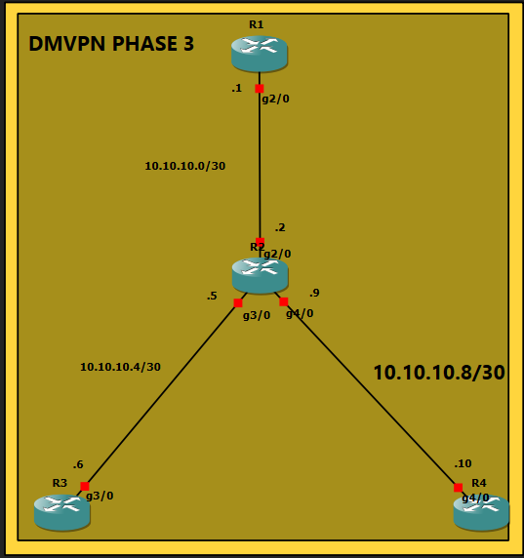

ISAKMP
To begin with, IKEv1 (the classic ISAKMP configuration) or IKEv2 must be configured, in this lab would be ISAKMP, this configuration must match in every router where dmvpn is being implemented.

HUB R1:
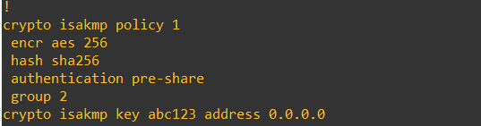

SPOKE R3:


SPOKE R4:


IPSEC
IPSEC must also match configuration in every router where DMVPN is implemented.
Hub R1:
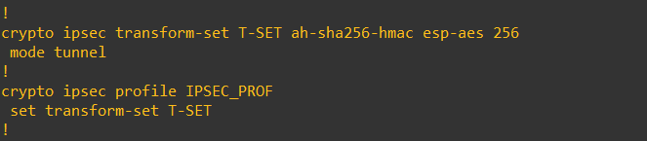

TUNNEL INTERFACE CONF
The difference is here, when you configure the interface Tunnel on the router HUB the configuration of NHRP is crucial, there are not big differences but is still something to consider making nhrp and dmvpn work.
HUB R1:
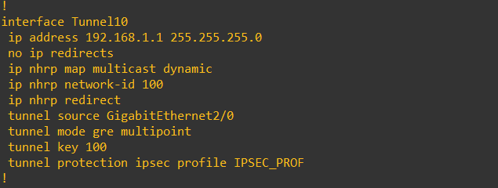
SPOKE R3:
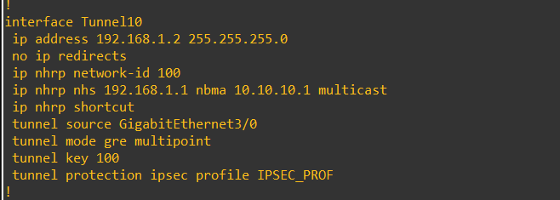
SPOKE R4:
